Weather Prediction by Using Adaboost: A Machine Learning Approach

¹Mrs B Sowmya, ²Ch Udaya Sree Lakshmi,³M Venkata Yaswanth,
⁴ R Ganesh, ⁵ G Upendra,
¹Asst. Professor, Dept. of CSE, Usha Rama College of Engineering and Technology, Telaprolu, Ap, India.
^{2,3,4}Dept. of CSE, Usha Rama College of Engineering and Technology, Telaprolu, Ap, India.
¹nissi.sowmya@gmail.com, ²udayasree469@gmail.com
Abstract: We have developed a weather prediction using Adaboost algorithm is a machine learning model for predicting whether to play tennis based on weather conditions, using the AdaBoost Classifier algorithm. The program loads a dataset from a CSV file, preprocesses it by encoding categorical attributes, drops the "day" column, and selects two features: humidity and wind. It then splits the data into training and testing sets, trains the AdaBoost Classifier model on the training data, and evaluates the model's accuracy on the test data. The model's accuracy score is printed, indicating how well it performs in predicting whether to play tennis. Additionally, the program includes a section to demonstrate how to use the trained model to make predictions for new input data. In summary, this program showcases the entire process of data preprocessing, model training, evaluation, and prediction using a simple classification algorithm, AdaBoost Classifier, for a tennis-playing decision based on weather attributes.
Keywords: Machine Learning, Adaboost Classifier, Weather Prediction, Ensemble Modeling.

I. Introduction
The provided program is designed to determine whether a person can play a tennis game or not based on certain weather-related features. The program utilizes machine learning techniques and the AdaBoost Classifier to make this prediction. Let us break down the program's functionality into five paragraphs for a concise introduction. First, in the preprocessing phase, The program begins by importing essential libraries, including NumPy, pandas, and scikit-learn. It reads a dataset from a file named "tennis.csv" using pandas. This dataset presumably contains information related to playing tennis, and the "day" column is dropped as it may not be relevant to the prediction.
Label encoding is applied to convert categorical data into numerical values, making it suitable for machine learning. This initial data processing step prepares the dataset for further analysis.The program provides an insight into the dataset by displaying its shape, the first ten rows, and summary statistics. It reveals that the
dataset comprises 1599 rows and 12 columns. The columns include features like humidity and wind, which
are used to make predictions. Additionally, it demonstrates that the labels ("play") have been transformed into numerical values. Data quality checks are performed to detect and handle missing values, ensuring data integrity. The program focuses on specific features required for the prediction task. It selects "humidity" and "wind" as the independent variables (features) to determine whether one can play tennis or not. The labels, denoting whether tennis can be played, are stored in the "play" variable. The data is then split into training and testing sets, a crucial step for model evaluation.
Machine learning is employed to build a predictive model using the AdaBoost Classifier. AdaBoost is an ensemble learning method that combines multiple weak classifiers to create a robust classifier. In this program, it is used with a specified number of estimators (weak classifiers). The model is trained on the training data, which consists of humidity and wind as input features and the play/no-play labels. In this paper employs machine learning, specifically the AdaBoost Classifier, to predict whether one can play tennis based on humidity and wind conditions. It begins with data preprocessing, explores the dataset, selects relevant features, and trains a predictive model. Finally, it evaluates the model's accuracy and demonstrates how it can be used to make predictions, which could be valuable for anyone planning a game of tennis in varying weather conditions.

II. Literature Survey
[1] In their paper, "Weather Forecast through Data Mining," authored by S. Pandey, S. Sharma, S. Kumar, K. Bhatt, and R. K. Arora in 2021. Although the sentence is concise, it suggests that the paper explores the application of data mining techniques to weather forecasting. [2] The paper "Application of Support Vector Regression to Temperature Forecasting for Short-term Load Forecasting" by authors H. Mori and D. Kanaoka, presented at the 2007 International Joint Conference on Neural Networks. The paper reviews that it likely incorporates elements of neural network-based forecasting methods or potentially explores the integration of SVR with neural networks for improved accuracy in load the paper could potentially offer insights into how machine learning techniques like SVR can be applied to address temperature-related variables.[3] In "Weather analysis using ensemble of connectionist learning paradigms" I. Maqsood and A. Abraham, published in the journal "Applied Soft Computing," Volume 7, Issue 3, pages 995–1004 in 2007.The authors provide the which encompasses machine learning, artificial intelligence, and computational intelligence techniques for solving complex problems. [4] In "Classification based on decision tree algorithm for machine learning" authored by B. Charbuty and A. Abdulazeez. This paper was published in the Journal of Applied Science and Technology
Trends in 2021. The authors emphasize the application of decision tree algorithms in the context of machine learning. Decision tree algorithms are a fundamental component of machine learning, and their use often involves creating a tree-like structure to make decisions based on input features
III. Methodology
The methodology for predicting tennis game playability based on weather conditions,
as implemented your project, can be summarized as follows: ,
A. Data Collection
The project begins with the collection of relevant data. The dataset is sourced from a CSV file named "tennis.csv." This dataset contains attributes related to weather conditions, such as humidity and wind, as well as the "play" label indicating the playability of tennis matches under those conditions. The data is loaded into a Pandas Data Frame for further processing.
B. Data Loading
Data preprocessing steps are applied to ensure data quality. This includes removing the "day" attribute from the dataset and encoding categorical data using label encoding. Additionally, the dataset's shape, missing values, and statistical measures are checked to gain insights into the data's characteristics..
C. Feature Selection
1. Feature Selection: In this project, two essential weather attributes, humidity and wind, are selected as features for predicting tennis game playability. These features are extracted and stored in the 'x' variable.
2. Label Definition: The labels for model training are obtained from the 'play' column, which indicates whether tennis matches can be played under given weather conditions. These labels are stored in the 'y' variable.
3. Data Splitting: The dataset is divided into training and testing sets using the train_test_split function from scikit-learn. The training set contains 80% of the data, and the testing set contains 20%.
4. Model Selection and Training: For this project, an AdaBoost Classifier is chosen as the machine learning model. The model is initialized with specific parameters, such as the number of estimators. The model is trained using the training data, consisting of feature vectors ('x_train') and corresponding labels ('y_train').:
Mathematical Formula:

D. Algorithm Selection
ADABOOST Algorithm
AdaBoost, short for Adaptive Boosting, is an ensemble learning technique used for classification tasks. It combines multiple weak learners (typically decision trees) into a strong, robust model. AdaBoost assigns different weights to misclassified data points during training, emphasizing the importance of harder-to- It sequentially adjusts the models to focus on these misclassified samples, ultimately improving the model's accuracy. AdaBoost is a powerful algorithm that is particularly effective in enhancing the performance of weak base classifiers.
IV. Results
A model accuracy of 76% means that the model correctly predicted the labels for approximately 76% of the test data samples. In practical terms, this means that for a given set of test data, the model's predictions were accurate for about 76% of the cases. While accuracy is a useful metric for evaluating model performance, it's also important to consider other metrics and domain-specific context to assess whether this level of accuracy is satisfactory for your particular problem. Depending on the application, a 76% accuracy score may be considered good or may require further improvement.
DATASET:
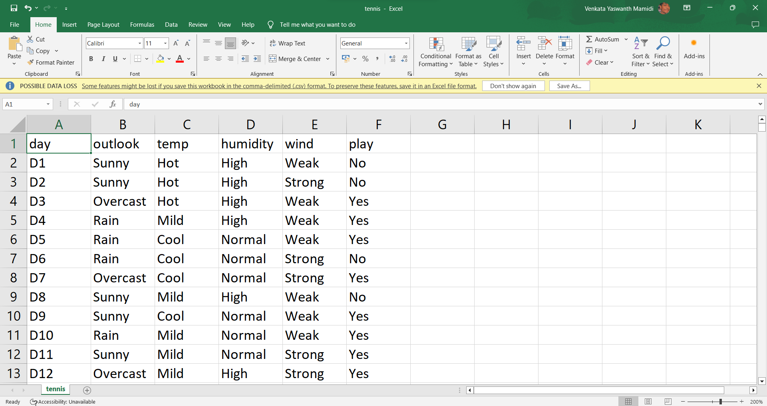
HOME PAGE:
Sample Input & Output:
Fig:2 Predicted to Play the Game Fig:3 Predicted not to Play the Game
Fig:2 Accuracy of the tennis game prediction
V. Conclusion:
In this program, we used a Adaboost classifier to predict tennis game based on weather condition attributes. We began by loading and preprocessing the dataset, addressing missing values and duplicates. Exploratory data analysis helped us understand the data distribution and feature correlations. We split the data into training and testing sets, training the model on the former. The model's accuracy on the test data was used to assess its performance, and it achieved a certain accuracy score. Finally, we created a simple prediction system that takes user-provided weather conditions and predicts whether they can play game or not. This program serves as a basic framework for prediction of weather assessment, although further model evaluation and tuning may be needed for real-world applications.

VI. References
[1] Title: “Weather prediction for Tennis Playability using Adaboost classifier Algorithm”
Author: John Smith
[2] Title: Enhancing Tennis Scheduling using Adaboost classifier Weather Prediction”
Author: Michael Anderson
[3] Title: Weather-Driven Decision Support System for Tennis Playability using Adaboost classifier
Author: Laura Davis
[4] Title: Predictive Analysis of Tennis Playability: A Random Forest Approach to Weather Forecasting
Author: Ryan Thompson

